6. Tuples, Sets Manipulation

Table of Contents

|  |  |  |
| --- | --- | --- |
| Sl. No | Topics | Page No |
| 6.1 | **Tuples Manipulation** | **2** |
| 6.2 | **Set Manipulation** | **8** |

## 6.1 Tuples Manipulation

**What is Tuples?**

A Tuple is a sequence of immutable Python objects. Tuples are sequences, just like lists.

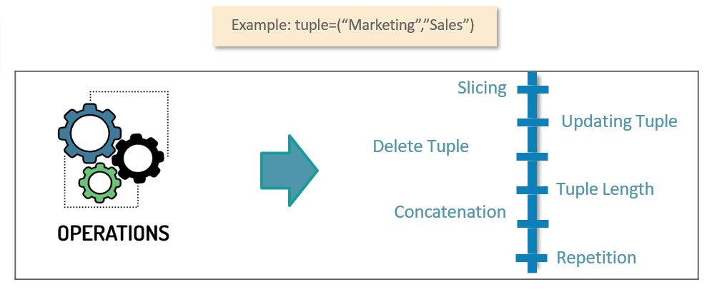

**When to use Tuples?**

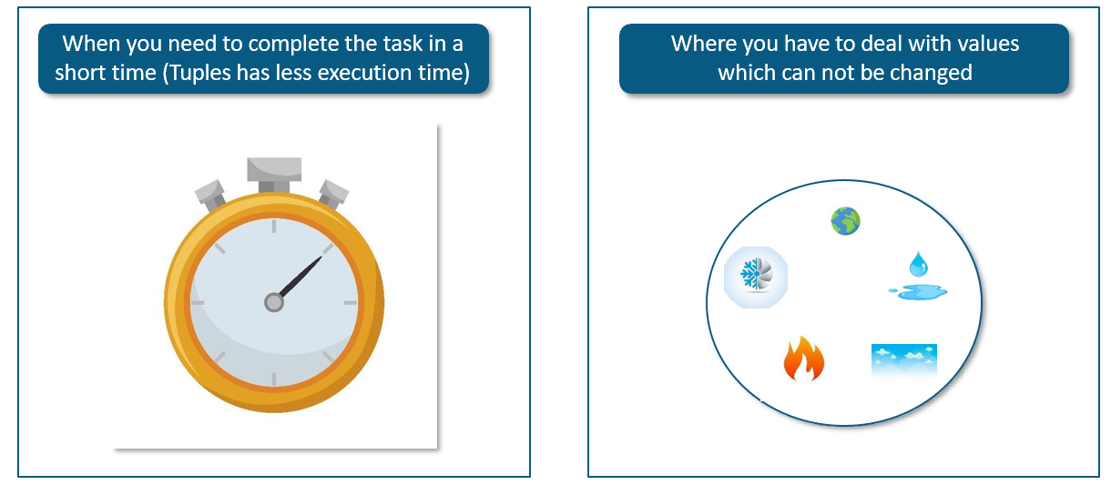

**I have a constant set of values and I have to iterate through them, what to do?**

A Tuple is a collection of constant values and speed of execution of Tuple is fast as compared to other sequences. So for John, Tuple will be the best choice

**Tuples - Built-in Tuple Functions**

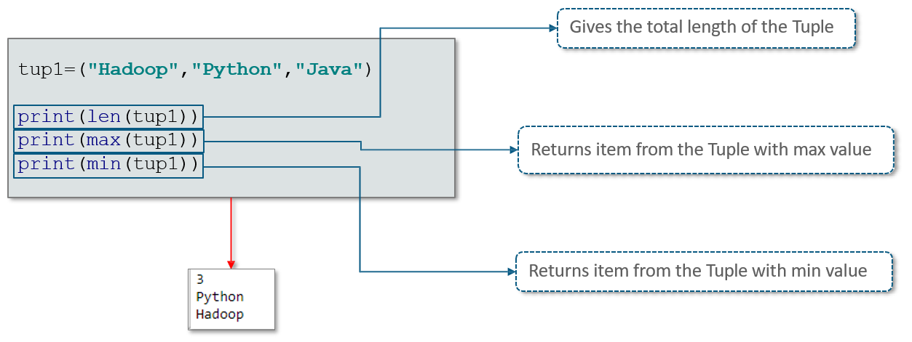

**Tuples – Sorting and Reversing**

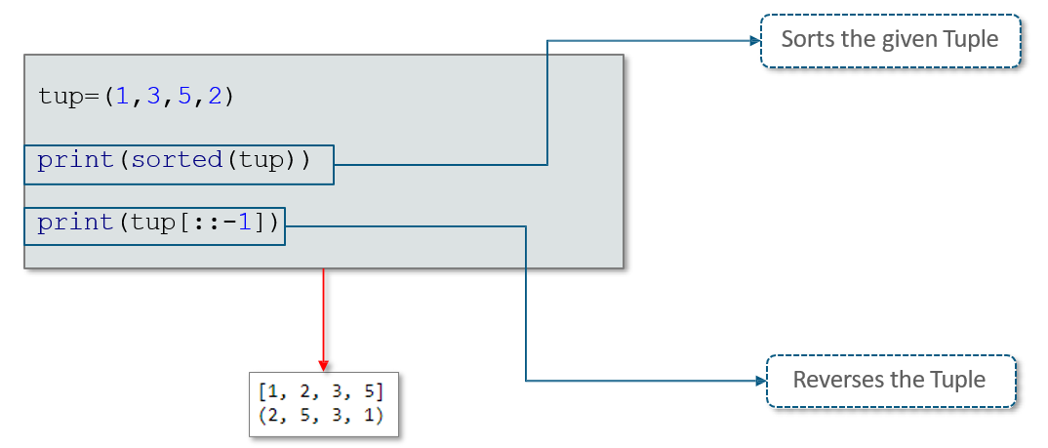

**Basic Tuple Operations**

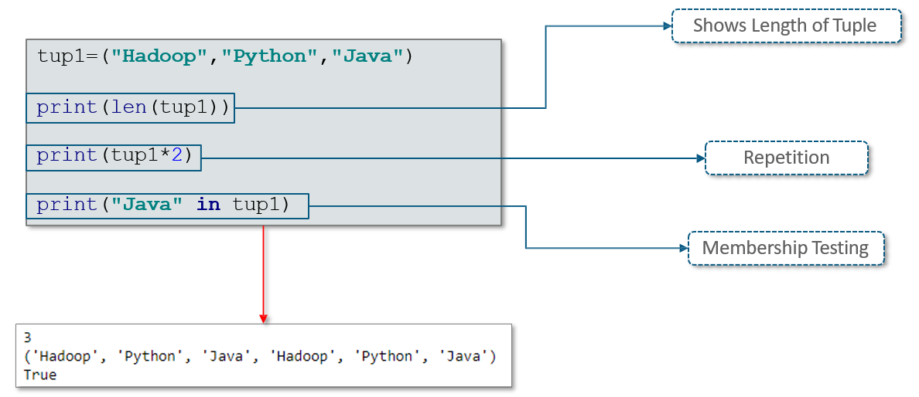

**More Operations Performed on Tuples**

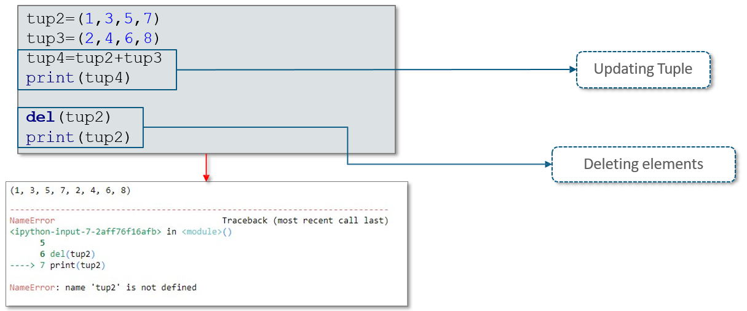

**Difference between Lists and Tuples**

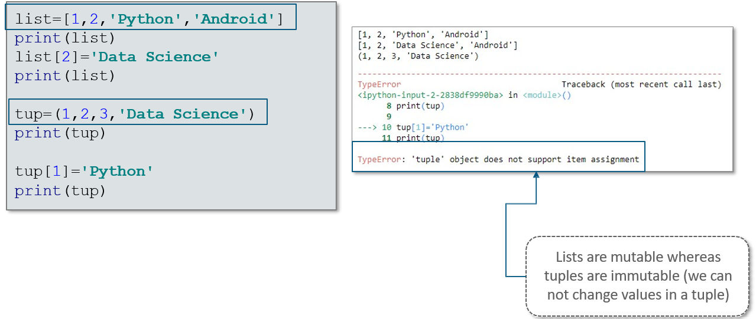

**A List inside a Tuple**

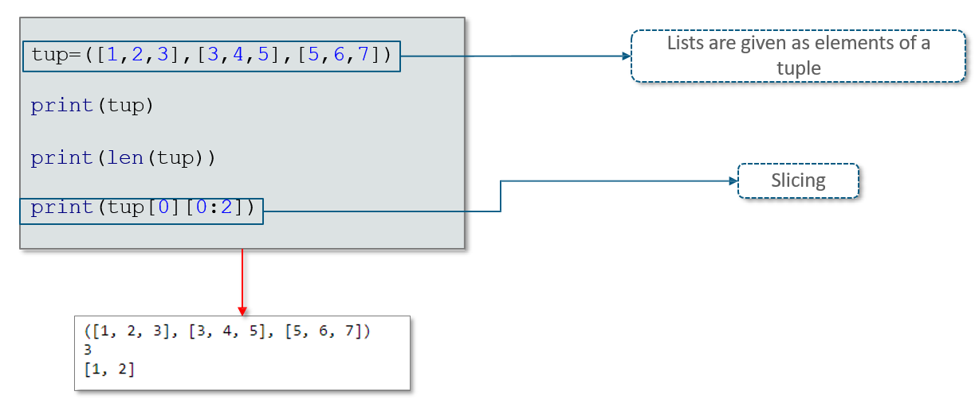

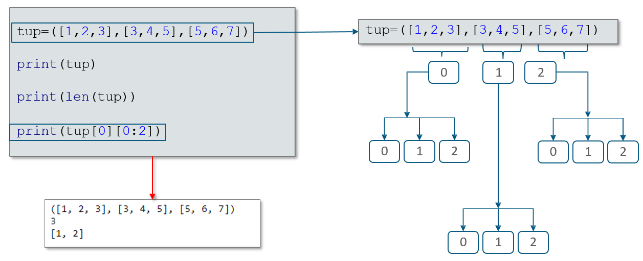

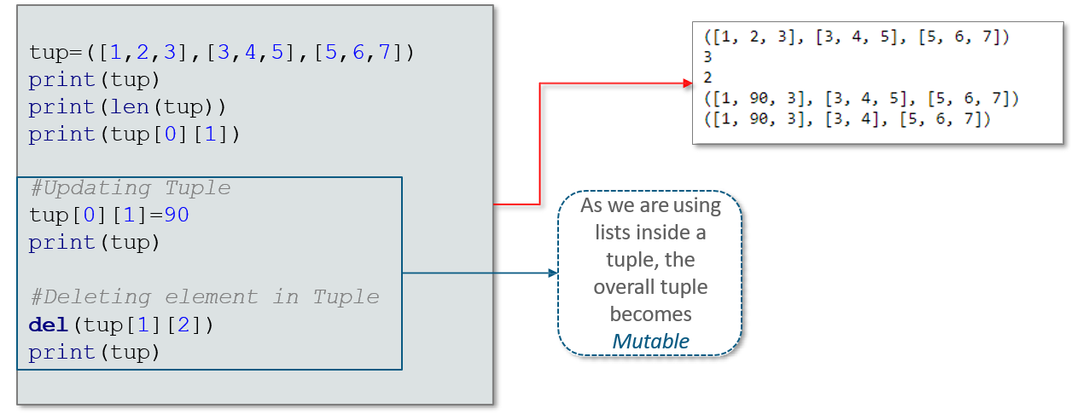

**Converting Tuples into Lists**

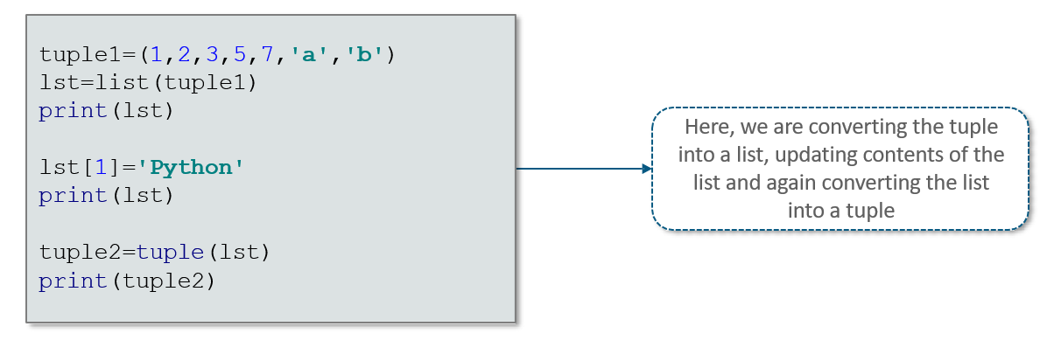

## 6.2 Sets Manipulation

**What is Sets?**

Set is an unordered collection of unique items. Set is defined by values separated by comma inside braces { }

Sets can also be created by calling the built-in set function:-

x=set(‘Welcome to Python’)

Print(x)

**When to use Sets?**





**Set Operation – Union**

Union of A and B is a set of all elements from both Sets. Union is performed using | operator.

Consider the below example:-

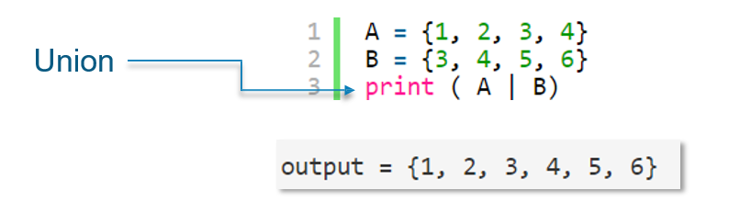

**Set Operation - Intersection**

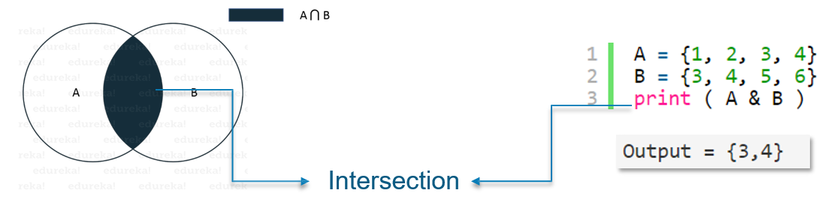

**Set Operation – Difference**

Difference of A and B (A – B) is a set of elements that are only in A but not in B. Similarly, B – A is a

set of element in B but not in A

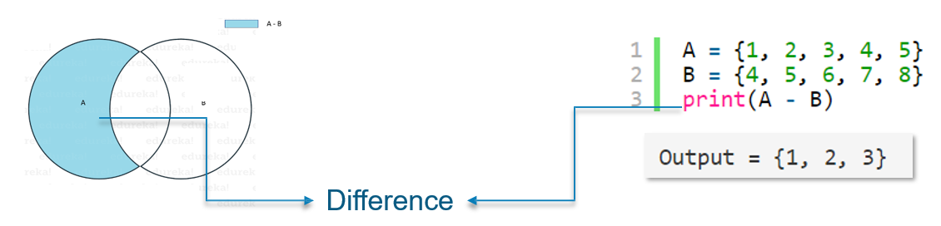

**Operations Performed on Sets**

